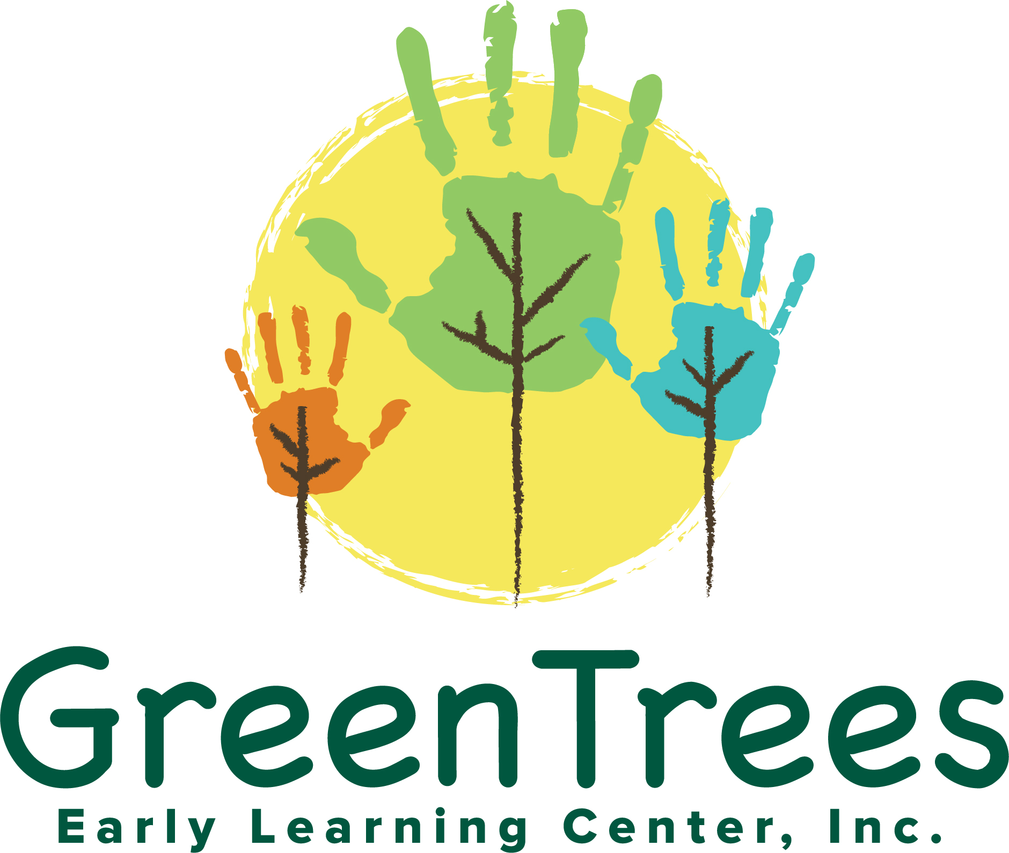

Green Trees Early Learning Center, Inc.
102 State Route 2001, Milford, PA 18337
Phone- 570-296-9040
www.GreenTreesELC.com

Curriculum Statement

The Green Trees Early Learning Center, Inc is a non-profit child care center designed to provide quality child care to the families of students’ ages 6 weeks through 12 years of Milford Pa and surrounding areas. We provide services for primarily ELRC and Head Start, as well as Private Pay students. We also work with the Center for Developmental Disabilities to provide wrap-around care for special needs students. Located in heart of just outside of Milford, PA, the program provides children with unique opportunities to interact with their surroundings and take advantage of hands-on science and nature learning experiences.

The program philosophy indicates that children learn through play and through experience. The process based curriculum and teaching mode stresses the significance of the experience, not the product of an event. The goals of our curriculum are multi-faceted. Our goals encourage children to be enthusiastic, self-confident, and independent learners. Our curriculum also respects individual learning styles and ever-changing interests. Through our curriculum we promote growth in all areas of development including:
Social: to help children learn from adults and one another by observation, imitation, and interaction.
Emotional: to provide a safe and secure environment where children can develop pride, self-confidence, independence, self-control, and a positive attitude.
Cognitive: to promote curiosity and to help children acquire learning skills, such as the abilities to solve problems, ask questions, and express their ideas, observations, and feelings.
Physical: to help children develop and enhance their small and large muscle skills and feel confident and comfortable with their own bodies.
Our curriculum goals are achieved through integrated, theme-based activities and conversations with adults and children. We utilize the Funshine Express: Buttercups and Fireflies model to incorporate the PA learning standards into lesson planning as well as student feedback and interest. Lesson plans specifically reference Learning Standards and each classroom teacher is provided with the appropriate standards for that group. Standardized lesson plan templates and Crosswalk guide for Funshine Express are available digitally for the staff. Teacher directed activities are individualized yet still are linked to key learning areas. Lesson plans are submitted the Friday prior to the lesson week ensuring advanced planning and purposeful activities. The manner in which the environment is organized and the process of the daily schedule also augments our goals. Opportunities exist within the classroom for the child to engage in one-on-one activities with the teacher, small group and large group activities, solitary and independent play. Whole group activities are for short periods of time and are suited to the age and ability of the children. Supervised free play and small groups predominate as a means of encouraging educational interaction.

Our early childhood classrooms are arranged into distinct interest areas or “centers” composed of Literacy, Manipulatives, Dramatic Play, Blocks, Art, Music, Sensory, Science, and math materials that expose children to purposeful play experiences. These classroom areas allow the children to make clear choices as they proceed. Our classrooms present open-ended activities so that each child can be challenged at his or her present level of development. The teachers plan the activities of each classroom based on their observations and the special interests of the children. The materials used are concrete, real, and relevant to the lives of the children. The learning process involves active, hands-on exploration. Concepts and experiences a child achieves in one area can be transferred and applied to other learning areas within the classroom and throughout life.
In each learning center the child develops and explores. The following examples provide insight into how play progresses toward learning.
Math Children have time to explore a wide variety of materials in order to develop math concepts. They learn concepts and skills in a developmental sequence appropriate to each child. Teachers change materials to provide experiences with new concepts. Use of math manipulatives helps to develop the skills of patterning, number concepts sorting/classifying, etc.
Science The curriculum encourages experimentation fostering cognitive development through observation, problem solving, questioning, probing, classifying, exploring, and communication. Teachers vary the discovery environment, providing the children with magnets, insect collections, balance scales, etc. to keep them actively involved. Cooking experiences allow children to observe the physical changes of ingredients as they are added to a recipe.
Language Arts The teachers make activities and materials available for utilization by individual children and groups of children that create a foundation for reading, writing, speaking, and listening. The child is encouraged to communicate ideas verbally and with writing and pre-writing skills. By listening to a story and talking about what happened, children learn to love books, remember details, and express ideas. Conversation between children and with adults provides opportunities for expressing and validating ideas. Puppets, flannel boards, and big books enrich the process of language acquisition.
Art Art materials encourage individual expression and free choice. Art is often related to the unit being studied. The children have experiences with many media, including paint, markers, crayons, stampers, clay, wood, foam, and fabric. Art enables the child to symbolically represent something; this use of symbol is a factor in reading and writing readiness. As children create an art project, they can plan and implement an idea.
Music and Movement Music is offered in a variety of forms within the classroom. Large group singing of action songs, skill building songs, work songs, and finger plays allow the child to participate cooperatively in a group. Recordings of songs and music from classical, contemporary, ethnic, and child-oriented genres play within the classroom during the day. Musical instruments offer individual children and groups of children experiences with sound and rhythm. The variety of music encourages children to develop individual preferences and develop an awareness of music as a form of expression. Creative movement opportunities enhance rhythm, challenge problem solving capabilities, and encourage creative imagination.

Block Center In the block center, children can explore cause and effect relationships as they build towers that tumble. Blocks enhance creativity by allowing the child to build representations of what they see; building a farm, fire station, or castle encourage the child to recreate the world around them. Children explore math concepts when they duplicate size relationships with unit blocks. Children explore science and weight concepts when they load a truck with blocks and dump them out again. Many language and social opportunities are presented as children explain the construction or banter and negotiate over ownership and process.
Dramatic Play Through dramatic play children have an opportunity to recreate life experiences from their perspective. When children pretend to be someone or something else, they understand their experiences better. Dramatic play projects all areas of the curriculum. Fostering socialization, sharing, and role playing are fundamental mandates of this center. Activities include dress up, kitchen set, dolls, animals, etc.

Library This center provides a quiet area within the classroom and a safe respite for some children. Children can browse through books and develop an interest in reading and an understanding of how a book works. As the child turns the pages of a book from beginning to end, he or she develops the concept of reading a book from left to right - a skill needed for reading and writing readiness.
Sensory Table A variety of medium in the sensory table enhances sensory awareness, as children sift, scoop, drip, and pour. When children fill a container to the brim and transfer the contents to another container, they experience volume relationships and fine-tune small motor skills.

Teachers make a wide variety of learning materials available to the children and change them frequently in order to assure that the children are continually challenged and stimulated in their learning and thinking. These child-accessible materials have labeled areas within the classroom in order to facilitate clean-up with the children's help. The child-safe and comfortable classrooms provide children with areas of quiet and activity. The prevailing atmosphere within each classroom is that of security, independence, and fun. We strive to foster independence skills and provide children with routine and structure. Daily activity schedules ensure that key learning areas as well as physical needs are addressed. These areas include free playtime, centers time, teacher directed activities, gross and fine motor experiences, music, sensory, rest, reading, and eating. The daily schedule of every classroom has certain guidelines and predictability. These factors allow the children to feel secure and independent. As stated previously in the activities section, teachers plan a variety of small group, large group, and teacher directed activities. An important component of a schedule is flexibility. Children's inquiries and interests and "teachable moments" all factor into the process of the day.
Outdoor environments present areas of sand for digging, slides and climbing equipment, dramatic play equipment such as play houses and kitchen sets to stir the imagination, open areas for running, picnic areas and quiet spots for day-dreaming and conversations, as well as a variety of foliage and plants for investigation. With safety a major concern, we have fenced in the entire playground area and have provided the toddlers a separate play area with appropriately sized equipment.

Modeling, conversing, and eye level interaction are key teaching strategies employed by our staff. We respect children’s individuality and learning styles. Teachers receive ongoing professional development in curriculum development, observations, environment, inclusion, diversity, and many other relevant topics as per our elective involvement in the Keystone Stars program. Teachers receive 18 hours of training per year to support their continued learning and skill development. We also encourage staff to continue their formal education by offering tuition support and guidance on applying for scholarships and aid.

Formal student assessments are conducted using the Funshine Express Progress Reports and Observation Reports for infant through pre-k classes. Observations of indicators and standards are conducted weekly, which build into the progress reports provided to parents in May and October. School age students are assessed using Green Trees progress reports or DHS Child Service Reports in May and October. Each child’s individual growth is tracked by the Director quarterly, utilizing the weekly observations. All observations and assessments of children then translate into the class’s lesson plans and areas of growth. These reports are shared with parents and parent/teacher conferences are offered in both fall and spring to allow parents’ access to teachers and provide input towards their student’s program development. By keeping class sizes small and providing teachers with an assistant we allow the teachers to work individually with students conducting activities based on the individual students’ needs while the assistant is engaging other students in play and learning experiences.

Updated 08/11/2020

